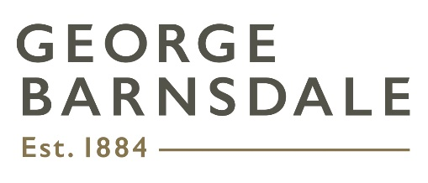HSEQ Statement of Intent

Management System

**Company Name:** George Barnsdale & Sons Ltd, George Barnsdale Commercial Ltd

**Effective Date:** March 2025

At George Barnsdale, we are committed to maintaining the highest standards of Health, Safety, Environment, and Quality (HSEQ) in all aspects of our operations. This Statement of Intent outlines our dedication to implementing and continuously improving an ISO-certified management system that aligns with the requirements of ISO 9001, ISO 14001, and ISO 45001.

**Our Objectives:**

Health & Safety:

* Provide a safe and healthy workplace, preventing injuries, illnesses, and risks associated with our operations.
* Foster a proactive safety culture by empowering all employees to identify and address hazards.

Environmental Responsibility:

* Minimise our environmental impact through sustainable resource use, pollution prevention, and compliance with environmental regulations.
* Continuously improve our environmental performance by adopting innovative and sustainable practices.

Quality Assurance:

* Deliver products and services that consistently meet or exceed customer expectations.
* Enhance customer satisfaction through effective processes, innovation, and continuous improvement.

**Our Commitments:**

* Comply with all applicable legal, regulatory, and ISO standard requirements.
* Establish, monitor, and achieve measurable HSEQ objectives and targets.
* Engage employees, contractors, and stakeholders to promote accountability and awareness of HSEQ responsibilities.
* Provide training, resources, and support to ensure competence in fulfilling HSEQ obligations.
* Maintain an open and transparent communication process with employees, customers, and other stakeholders.

**Responsibility:**

The Board of Directors and Management team are accountable for leading the implementation and continual improvement of the HSEQ management system. All employees and contractors are expected to uphold this commitment by adhering to HSEQ policies, procedures, and practices.

This Statement of Intent will be reviewed annually to ensure its ongoing relevance and effectiveness in supporting our strategic objectives.

**Signed:**

Tom Wright, Managing Director